Your child will need a copy of the beginning band method book “Standard of Excellence Book 1”, which has a RED COVER for their specific instrument (there are different books for flute, clarinet, trombone, etc.). You can purchase this book at virtually any local music store or online. You may choose the standard edition or the enhanced edition. The enhanced edition contains a cd with accompaniments for each of the songs and software that helps students with their practice. The enhanced edition makes practicing more fun and productive, but is NOT REQUIRED. The price for the book is $6.95 + tax for the standard edition, and $9.95 + tax for the enhanced edition.
Some suggested places to buy Standard of Excellence Book 1:
- Johnstonbaugh’s Music (They deliver to SES!) 724.444.5660
- Volkweins Music (They will deliver to SES!) 1.800.553.8742
- Atkins Music (Connellsville): 724.628.2450
- Vittone’s Music (Greensburg): 724.837.0877
- wwbw.com
- amazon.com

***MAKE SURE YOU BUY THE BOOK FOR THE INSTRUMENT YOUR CHILD IS PLAYING (Flute, clarinet, Drums & Mallets, etc.) ***

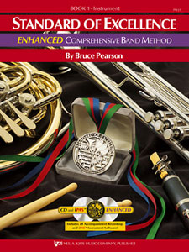

Your child will need a copy of the beginning band method book “Standard of Excellence Book 1”, which has a RED COVER for their specific instrument (there are different books for flute, clarinet, trombone, etc.). You can purchase this book at virtually any local music store or online. You may choose the standard edition or the enhanced edition. The enhanced edition contains a cd with accompaniments for each of the songs and software that helps students with their practice. The enhanced edition makes practicing more fun and productive, but is NOT REQUIRED. The price for the book is $6.95 + tax for the standard edition, and $9.95 + tax for the enhanced edition.
Some suggested places to buy Standard of Excellence Book 1:
- Johnstonbaugh’s Music (They deliver to SES!) 724.444.5660
- Volkweins Music (They will deliver to SES!) 1.800.553.8742
- Atkins Music (Connellsville): 724.628.2450
- Vittone’s Music (Greensburg): 724.837.0877
- wwbw.com
- amazon.com
***MAKE SURE YOU BUY THE BOOK FOR THE INSTRUMENT YOUR CHILD IS PLAYING (Flute, clarinet, Drums & Mallets, etc.) ***

